**Kol simcha torah gazette**

**For parshas bereishis 5784**

Volume 8 Issue 5 (Whole #363) 29 Tishrei 5784/ October 14, 2023

**Printed L’illuy nishmas Nechama bas R’ Noach, a”h**

For a free subscription, please forward your request to [***keren18@juno.com***](mailto:keren18@juno.com)

***Past emails can be found on the website ShabbosStories.com under Brooklyn Torah Gazette***

**Giving from the Heart**

**From Rav Nosson Tzvi Finkel**

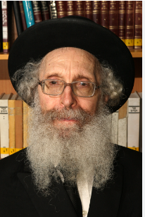 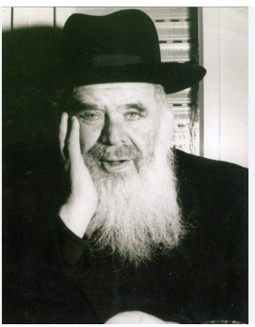

**Rav Nosson Tzvi Finkel and Rav Chaim Shmuelevitz**

Kayin brought his minchah offering from a lofty plane of spiritual appreciation, intuiting the secret of korbanos from his own mind and heart. Nevertheless, Hakadosh Baruch Hu did not accept his offering, since it was sorely lacking in quality, as Rashi interprets the words mipri ha’adamah to mean min hagarua — from the worst.

The rosh yeshivah, Rav Chaim Shmulevitz, observes that at this point in history, the only inhabitants of the world were Adam HaRishon and his wife and children, while the world itself was replete with a virtually endless array of the finest and most succulent fruits, grains, and produce.

Adam and his family couldn’t possibly have consumed even a tiny fraction of the great bounty that flourished all around them, and abandoning all the excess produce in the fields would leave it to rot.

**The Exalted Secret of Korbanos**

What prevented Kayin from offering the cream of his crop to Hashem, especially when it was he who originally grasped the exalted secret of korbanos and felt inspired to offer a gift to Heaven?

Rav Chaim explains that this is the innate nature of man. Even when a person is blessed with all the bounty and goodness in the world, he is reluctant to part with his possessions or share them with others. Furthermore, even when a person does share his wealth, he tends to be stingy and give with an ayin ra’ah.

The attribute of nesinah, giving from the heart, is so challenging for a human being to master that even when a person engages in this lofty spiritual form of giving — offering a korban to Hakadosh Baruch Hu — his nature would be to do so frugally, with an ayin ra’ah.

**Wouldn’t Your Friend Surely Be Insulted?**

If someone were to present low-grade produce as a gift to his friend, the friend would surely be offended. Why, then, was Kayin so shocked and dismayed that Hashem did not accept his korban? Kayin’s reaction stemmed from the same negative trait of stinginess that underpinned his offering. It is so difficult for a person to give genuinely from himself that even when he gives the bare minimum, he feels that he parted with everything he owns and that others owe him appreciation for his magnanimous gift!

Kayin presented the worst of his produce to Hashem, yet he still believed that his offering would be accepted graciously and with desire — because in his mind, he had given everything in the world. This is why the rejection of his korban caused him deep distress.

*Reprinted from the Parshas Bereishis 5783 edition of At the ArtScroll Shabbos Table. Excerpted from the ArtScroll book – “Insights on Chumash from Rav Nosson Tzvi Finkel.”*

**Rav Avigdor Miller on**

**Punishing Children**

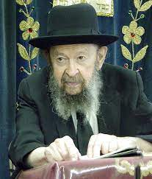

**QUESTION:** Which things require a child to be punished?

**ANSWER:** Very many things. Of course, you must know children are human beings, and children, even little children, have seichel. So often you can talk to them. If you talk mussar to them, again and again, it goes into their heads, yes. You talk to children it has an effect.

But sometimes, it goes in more deeply if you give a potch too. It says, “A rebuke goes into an understanding person, more than hitting a fool a hundred times” (Mishlei 17:10), but even hitting a fool helps it to go in too. So, when a man did a sin of malkos, and the shaliach bais din picks up his whip and hits him b’chol kocho, with all of his strength on his neck and back, it’s supposed to go through the back, into the body, and into his mind. That’s how it’s supposed to go.

And the person who’s being beaten should think, “I have to listen to that mussar. I should have listened to the mussar that I was taught by my father and mother. I should have listened to the mussar in the Yeshivah. But I didn’t, so now the mussar of the strap is teaching me an important lesson. It’s the Mesillas Yeshorim hitting me on the back.” He should think mussar thoughts.

Therefore, sometimes a little hit is good enough. Sometimes you need more. If a child does dangerous things, you have to hit him and hit him until he stops doing it. Because dangerous things, it’s piku’ach nefesh, danger to one’s life. What don’t you do to save a person’s life? Therefore, it depends on the kind of child, and it depends on the certain thing that he did. But there’s no question, sometimes punishment is very much justified.

*Reprinted from a recent email of Toras Avigdor based on Rabbi Avigdor Miller’s Tape #E-999 (February 1995) from his classic Thursday night lectures.*

**Why Did Adam and Eve**

**Disobey G-d’s Prohibition?**

**From the Teachings of the Lubavitcher Rebbe**

**Rabbi Menachem Mendel Schneerson, Zt”l**



The Midrash recounts the sequence of events that led to Adam and Eve's eating from the Tree of Knowledge, as narrated in this week's Torah portion, Bereishit: First the serpent approached Eve, and asked if G-d had forbidden them to eat all the fruit in the Garden of Eden. She replied that they were permitted to eat any fruit, except for those growing on the Tree of Knowledge: "G-d has said, 'You shall not eat of it, and you shall not touch it, lest you die.'"

When the serpent heard this reply, he pushed Eve towards the Tree and told her, "Surely you will not die."

The Midrash explains that Eve's mistake was adding on to G-d's command. The prohibition was only against eating the fruit of the Tree of Knowledge, yet Eve added that they weren't allowed to touch it. It was this initial digression that enabled the serpent to lead her astray, and later, for her to cause Adam to sin.

Our Sages tell us that the reason Eve made this mistake was that she didn't hear the command directly from G-d; it was transmitted only second-hand, through Adam. Had she heard it directly from G-d, not only would she not have sinned and led her husband to sin, she would have kept Adam from transgressing.

This is why, at the revelation of the Torah at Mount Sinai, G-d commanded Moses to give the Torah first to the Jewish women, then to the men. "Thus shall you say to the house of Jacob," G-d told him, referring to the Jewish women; "and tell the people of Israel," referring to the Jewish men. In this manner, G-d ensured that the Jewish women would always be on the forefront of Torah observance throughout the generations, and from their perspective, "correct" the sin of the Tree of Knowledge.

The special advantage of Jewish women - the ability to extend a protective and positive influence on their husbands - is derived from the way Eve was created, which was different from Adam. Adam was created from the earth, from a base substance, whereas Eve was created from Adam's rib, from the body of a human being.

Our Sages also interpret the verse "And the L-rd G-d built (vayiven) the rib" as relating to the "extra measure of wisdom (bina) that G-d has given women over men." Because women are on a higher spiritual level, they possess this ability to guard them.

This underscores how crucial it is to provide Jewish girls with a Torah-true education, instilling in them pride and a sense of joy in their Judaism. For the Jewish woman is the foundation of the home, and the positive influence she wields is very powerful.

*Reprinted from the Parshat Bereishis 5761/2000 edition of L’Chaim. Adapted from Volume 3 of Likutei Sichot.*

**G-d’s “Stamp” is Truth**

In the beginning G-d created (Bereishit bara Elokim) (Gen. 1:1)

In the same way that every author alludes to himself on the opening page of his work, so too has G-d set His seal at the very beginning of the Torah. G-d's "stamp," as it were, is "emet," truth - arrived at by rearranging the final letters of the words "Bereishit bara Elokim." *(Rabbi Bunim of Pshischa)*

**Rabbi Berel Wein on**

**Zot Habraha - Bereishit 5784**



Because of the intricacies of the Jewish calendar, the end of the Torah – Zot Habracha – and the beginning of the Torah – Bereshith – follow each other in rapid succession this week. This is a timely reminder to us of the seamlessness of Torah – an understanding that will help us appreciate all of the Torah portions that we will hear and study in this new and blessed year.

The rabbis of the Talmud have taught us that words of Torah which seem poor and unimportant in one Torah text contain rich and meaningful information and insight when viewed in the perspective of another text. Thus, the Torah has to be viewed in its totality and not only in analysis of individual and particular words and phrases.

The immortal greatness of Rashi’s commentary to Torah lies in its ability to present both the trees and the forest at one and the same time to its readers and students. Without knowing Bereshith, Zot Habracha descends into poetry and narrative devoid of its ultimate spiritual content and purpose. And without knowing Zot Habracha, Bereshith itself remains an unfathomable mystery of creation and primordial life without apparent purpose and relevance to later human generations.

That is what Rashi is driving at in his initial comment to the Torah. Creation had a purpose; G-d is not a random force in human existence, and Torah – the Torah of Moshe – and the continued existence of the people of Israel are integral parts of the purpose of creation and human life. Thus, these two parshiyot of the Torah, the last one and the first one, are intimately joined in the great seamless Torah that is our inheritance. Each one accurately describes the other.

The rabbis teach us that each individual person must always believe and say to one’s self that this entire wondrous universe was created only for me. By this they meant to reinforce the idea of the purposefulness of creation itself and of the role that each and every human being can play in determining the destiny of that process of creation. By fulfilling our role as devoted Jews, with a moral understanding of life and good behavior patterns, we inherit the blessings of our teacher and leader Moshe as well as becoming partners, so to speak in G-d’s handiwork of creation.

Nothing in life is wasted and even acts that we may deem to be somehow insignificant are important in G-d’s cosmic scheme of human existence. The blessings of Moshe are individual and particular. No two of them are alike. So too are human beings – no two of them alike. It is one of the many wonders of creation. Since the blessings are individual and human beings are unique, it is obvious that each of us has a role in the human story - each one of us individually. Thus, our own individual lives take on greater purpose, influence and meaning. And that is the true blessing of creation itself.

*Reprinted from the current website of rabbiwein.com*

**The Attribute of Truth**

The Midrash relates that before G-d created man the ministering angels broke into factions, some supporting the plan and others against it. The attribute of benevolence said, "Let him be created, for he will perform kind and loving deeds."

The attribute of truth said, "Let him not be created, for he is filled with falsehood." The attribute of justice said, "Let him be created, for he will seek justice."

The attribute of peace said, "Let him not be created, for he will only sow discord and dissention."

What did G-d do? He took the attribute of truth and flung it to the earth.

Commented Rabbi Menachem Mendel of Kotzk: This teaches that truth cannot be attained by "standing tall" and insisting that one's opinion be accepted; the only way to reach it is by "bending down" and being humble.

*Reprinted from the Parshat Bereishis 5761/2000 edition of L’Chaim.*

**Ancient Pagan Antisemitism**

**By Mark Shiffer**



Antisemitism is one of the world’s oldest hatreds. It stubbornly persists into modern times. How did it start and where did it come from? That is difficult to answer.

The Talmud teaches that Sinai, the mountain where the Jews accepted the Torah, comes from the Hebrew word “*sina,”* which means “hatred.” After receiving the Torah at Mount Sinai, which gave concepts of morality, hatred of the Jews descended on the world.

**Jew Hatred as Old as the Jewish Diaspora**

No doubt [Jews in the ancient world were viewed as different](https://aish.com/jewish-ideas-that-transformed-the-world/) based on their unique belief systems. The 19th century German historian, Theodor Mommsen, claimed that Jew-hatred and agitations against the Jews were as old as the Jewish diaspora itselfi.

Judaism was an abnormality in the ancient polytheistic worldii. Jews were sometimes blamed for the “anger of the gods” when natural disasters struck. They were seen as strange because they had no statues and worshipped an invisible deity.The Torah relates the fear and loathing of the ancient Egyptians towards the Israelites.

Most pagans were willing to absorb new deities introduced by conquering armies. Jews as monotheists refused to do so. Dietary laws prevented Jews from eating with their pagan neighbors. Jews were considered lazy for not working on the Sabbath. While different cultures intermarried, absorbing each other’s idols, Jews remained separate. Jews were the ultimate nonconformists in a sea of paganismiii.

Scholars often called pagan hostility to Jews anti-Judaism rather than the more modern term antisemitism. But here, we will refer to hatred of Jews as antisemitism to avoid confusion.

The most numerous written sources of antisemitism in the pagan world came from the Greco-Roman period. This was a time after the Babylonian expulsions when many Jews lived outside the Holy Land in various diasporas and mixed with other cultures.

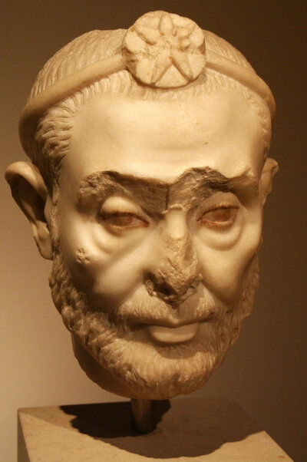

**Maetho and Josephus**

One of the earliest antisemitic sources came from a Greek speaking Egyptian priest living in the early third century BCE named Manetho. Manetho wrote a history of Egypt, devoting a section to the Israelites and the Exodus. Much of Manetho’s writing has been lost but was referenced by the ancient Jewish historian Josephus.

In his version of events, Manetho turned the Exodus story upside downiv. Instead of a tale of Jewish liberation from Egyptian slavery, Manetho wrote a scathing version where the Egyptian gods expelled the Israelites to purify Egypt. Before expulsion, the Jews under a rogue prince named Moses, terrorized the Egyptian people, and blasphemed their gods.

One of the larger ancient Jewish population centers was in Alexandria, Egypt. Alexandria was hub of learning, focused at the great ancient library of Alexandra. It was also the hub of much tension between Jews and pagans living there.

**Josephus Defense of the Jews**

Once again from Josephus, we understand that a man named Apion was an official of the Alexandria library and wrote a scathing polemic against the Jews. Among his writings, Apion claimed the Jews of worshipping a donkey’s head in the Jerusalem Temple. Josephus spilled much ink defending Jews against the accusations of Manetho and Apion.

In a more chilling libel that would have serious implications through history, Apion accused Jews of kidnapping Greek children and offering them for human sacrifice in the Templev. Tensions between Greeks and Jews in Alexandria continued to simmer until war broke out between the two groups in 115 CE.

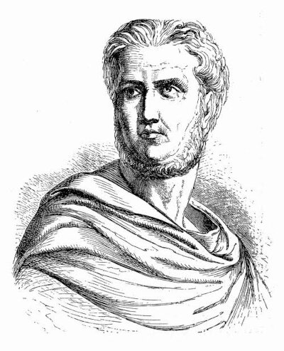

*Tacitus*

The famous Roman historian Tacitus, devoted large segments of his writing to criticize Jewish practices. Tacitus lived at the time of the Second Temple and wrote his *Histories* decades after its horrific destruction. He wrote that the gods despised the Jews. Tacitus believed Jews hated everything held sacred by Rome. He called Jewish rites “sordid and ridiculous.” He claimed Jews were the “most despised people and basest of nations.” While many pagan writers and orators scorned Jews and Judaism, Tacitus’ polemic is particularly viciousvi.

**Maligning the Origins of Judaism**

There seemed to be several themes in pagan antisemitism, some of them still used against Jews in today. One theme was to malign the origins of Judaism. There were repeated attempts to downplay or degrade the events that led to the formation of the Jewish people and their attachment to the land of Israel.

Another form of attack alluded to what the pagan world perceived as the strangeness of Jewish practises. The concept of taking one day off each week for the Sabbath was seen as ridiculous, particularly when applied to the lower classes and slaves. That many Jews throughout the Roman Empire were poor only added to derision. [Circumcision](https://aish.com/bris_milah_beautiful_or_barbaric/) and abstaining from eating pork were also misunderstood and considered “barbaric.”

One area that especially stirred up hatred was proselytization. In later antiquity Jews did it with some success. Tacitus complained about Jewish proselytizing, warning that those who accept the Jewish faith “despise the fatherland.”vii Oddly, one of the accusations leveled against Jews was that they practised “atheism” and caused others to convert to these beliefs.

There is significant evidence to argue that ancient pagan antisemitism was widespread. The tragedy is that many pagan forms of antisemitism morphed and adapted through history. Christianity, Islam, and secular societies often built upon pagan hatreds and continued to use the same methods to attack Jews and Judaism.

Reprinted from the September 26, 2023 posting on aish.com

**Influencing Other Jews**

**to be More Jewish**

And G-d blessed them, saying, be fruitful and multiply (Gen. 1:22)

The first mitzva in the Torah is the commandment to be fruitful and multiply. From this we learn that the first responsibility of a Jew is to ensure the existence of another Jew in the world, and to try to influence other Jews to be "more Jewish." *(Rabbi Shneur Zalman of Liadi)*

*Reprinted from the Parshat Bereishis 5761/2000 edition of L’Chaim.*

**From Bread Lines to Blessings: How I Learned**

**to Be Grateful for Food**

**By**[**Sofya Sara Esther Tamarkin**](https://www.chabad.org/search/keyword_cdo/kid/23400/jewish/Tamarkin-Sofya-Sara-Esther.htm)

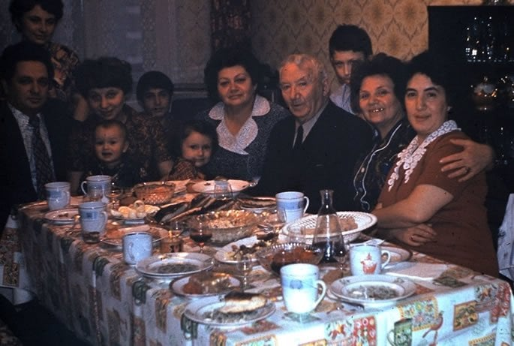

**A family gathering in Soviet Russia.**

Growing up in the former Soviet Union, every adult I knew spent their free time standing in long lines for basic provisions. I distinctly remember my grandmother waking up before dawn to get in line for fresh milk. The Soviet reality wasn’t for the lazy. Being in line didn’t guarantee that there would be enough for everyone waiting. If you overslept and got in line late, you had to wait until the next time.

We constantly worried about rationing the next meal.

Milk was in high demand; it was used to make cottage cheese, butter and kefir that resembled yogurt. (Really, everything was in high demand!)

Poultry was a treasure. It was a craft to cook one chicken in five different dishes—bones in a soup, skin as a kishka, organs sautéed with onions, meat ground and mixed with bread for patties, and small leftover pieces mixed into a pot of noodles.

When people obtained flour and margarine, they baked bread, pies, cookies, cakes and whatever else they could to feed their families. Summers were spent on small, government-distributed plots of land with tiny bungalows and dachas, where people toiled day and night to grow fruits and vegetables. Then these crops were boiled, canned, jammed, dried and salted.

**Fishing with My Father on the Volga River**

Everything was salvaged and preserved for the hungry winter months. Our [dacha](https://www.chabad.org/theJewishWoman/article_cdo/aid/4651883/jewish/Yuri-Gagarin-and-an-Extraordinary-Ordinary-Life.htm) was located on the Volga River. My father and I spent time fishing so we could cook meals with whatever we caught from the river. Fish was also salted and dried for the winter months. Candy, chocolate and ice-cream were almost never available. Soviet children received special goody bags at government New Year’s celebrations. Inside were a few tangerines and chocolate candies. It was a “generous” once-a-year treat from the Communist party.

This was the Soviet reality, and adults were used to it. The government wasn’t interested in complaints. In 1989, my family went through two [refugee camps](https://www.chabad.org/theJewishWoman/article_cdo/aid/4575425/jewish/The-Egypt-of-My-Childhood.htm) in Austria and Italy, where again there was a shortage of food.

For the first 13 years of my life, I often fell asleep dreaming about a mysterious world where food, particularly sweets, was available anytime I wanted. In my imagination, people never had to worry about rationing.

**Completely Overwhelmed by a Visit to a Small Grocery Store in the U.S.**

A few days after arriving in the United States, my grandmother [Zelda](https://www.chabad.org/theJewishWoman/article_cdo/aid/4809151/jewish/The-Sweet-Lull-of-My-Soviet-Grandmothers-Lullaby.htm) and I went to a small grocery store near our apartment in Philadelphia. I was completely overwhelmed when I walked through the snack aisle. I had never seen so many varieties, colors, shapes and flavors. It simply took my breath away.

Many years have passed, and I still love to stroll through supermarket aisles looking at the rows of colorful products. When I embraced my Jewish heritage and began to learn about Torah values, I connected to the mitzvah of [reciting a blessing](https://www.chabad.org/library/article_cdo/aid/90257/jewish/Brachot-Blessings-for-Food-Other-Occasions.htm) before eating. It felt inherently natural to channel my appreciation into words of gratitude.

This [mitzvah](https://www.chabad.org/library/article_cdo/aid/1438516/jewish/Mitzvah.htm) was my way of showing gratitude for the fulfillment of my childhood dream of having access to a plentiful diet any time of the year. I noticed that after reciting the blessing, I became more mindful, and the eating experience itself was enhanced by the pause.

I learned the different blessings that are said. For things that grow [in the ground](https://www.chabad.org/library/article_cdo/aid/278546/jewish/Borei-Pri-Haadamah-The-Blessing-on-Vegetables.htm), including vegetables, legumes, peanuts and berries, versus fruits that [grow on a tree](https://www.chabad.org/library/article_cdo/aid/278545/jewish/Borei-Pri-Haetz-The-Blessing-on-Fruits.htm), such as apples or cherries. In Jewish law, a tree fruit is defined as something growing from a perennial tree that does not renew its stem and does not grow too close to the ground. At times, when I wasn’t clear on what blessing should be recited, I [searched for clarifications](https://www.chabad.org/library/article_cdo/aid/4265961/jewish/What-Is-the-Blessing-on-Bananas-Strawberries-Grapes-Berries-Etc.htm).

**Still Have Not Tried Every Flavor of Cereals**

After arriving in the United States, we were surprised to discover that the most popular breakfast food was called cereal. After being taught how to eat it with milk, we bought whatever flavors were on sale every week. Thirty-five years later, I still have not tried every flavor. Now, before biting into a crunchy spoonful, I stop and say the [blessing](https://www.chabad.org/library/article_cdo/aid/278543/jewish/Mezonot-The-Blessing-on-Grains.htm) for foods that are made from grain, such as wheat, barley, rye, spelt or oats.

Perhaps my favorite blessing is the one recited before eating chocolate, ice-cream and candies. (It is also said for food that does not grow from the earth, such as meat, chicken, fish and eggs.) I say these words with intention—to remind my inner child to be grateful for all the sweets—and sweetness—in our lives.

Another favorite is the [blessing](https://www.chabad.org/library/article_cdo/aid/278544/jewish/Borei-Pri-Hagafen-The-Blessing-on-Wine-and-Grape-Juice.htm) over wine. When my family lived in the refugee camp in Austria, we again had to ration for meals. One day, there was a local harvest celebration and farmers carried crops of grapes through the main street of the town. Together with other immigrants, we stood on the side of the road, as wagons with grapes rolled by.

**Bags Filled with Sweet Grapes**

Clusters of luscious grapes were thrown into the crowd, and soon our bags were filled to capacity. I remember the joy of eating sweet grapes for days. My stomach was full, and it was immensely satisfying. After a while, the fruit began to spoil, and my father decided to ferment it into wine. Later, I learned that wine deserves its own special blessing.

Rabbi Isaac Luria, the famous “Ari,” taught that everything in this world possesses a spark of G‑dly energy that creates its essence. When a person utilizes food towards a G‑dly end and pauses to say a blessing, this holy spark is released, fulfilling the purpose for which it was created.

The next time you’re about to bite into an apple, sandwich or chocolate bar, create a mindful space for gratitude. Say a blessing for the food in front of you; pause and appreciate its color, shape, smell and nutrients. After you recite the words of prayer, experience its texture, taste and flavor. Savor this moment as a banquet created for your pleasure and enjoyment.

Reprinted from the Chabad.Org website.